3/22/2010 9:36:55 PM

Exchange 2007 is a different beast. I find that it only delivers in TNEF (Envelop) format. That could put a crimp in the works except that we can still use Outlook to get to the emails and that will work for you just fine.

And of course, I am starting tonight to write yet another converter for the embedded RTF (enveloped) attachment sent from Exchange Server 2007.

Below explains the 2003 setup. We were expecting this, but MS made a drastic architectural change.

Standard message-only journaling simply delivers a copy of a message flagged for archival to a designated journal mailbox. Envelope journaling instead delivers archival messages using an envelope message containing a journal report with the original message as an attachment.

Envelope Journaling is available in Exchange 2000 Service Pack 3 and Exchange 2003 Service Pack 1 and later. Exchange Envelope Journaling is used to capture all the available RFC2821 and RFC2822 recipients, including CC and BCC recipients that were configured on an email message. It also captures members of a distribution group expansion and it captures reports that include delivery receipts, NDRs, read receipts, and out-of-office notifications.

Envelope journaling enables you to archive the following information to specified journal mailboxes:

* All the recipients of the message (P1 data as contained in the Simple Mail Transfer Protocol (SMTP) conversation)
* Distribution group lists are completely expanded and included in the above list The journaled message consists of a multi-part Multipurpose Internet Mail Extensions (MIME) message with the following contents:
* Plain text that contains information about the complete list of P1 recipients, the recipients specified in the SMTP conversation by the RCPT TO: command, and original message ID.
* The original message as attachment

It's easy to see the difference between the two:

This is a journaled message - see how it looks exactly like the original message, but it lacks all the additional protocol information:

# Standard Journaled Email

This is what you want.

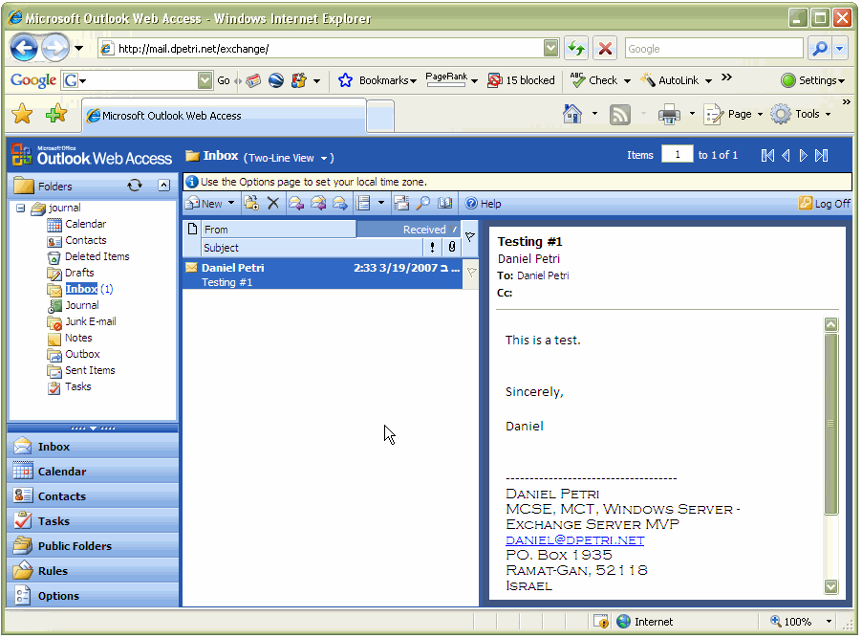

# Enveloped Journaled Email

This is what we have now.

